**Phone Book Application**

**PROJECT BY: -**

**Aryan Pratap Singh(RA2111003010106)**

**Introduction:**

This programme uses files as database to perform file handling operations such as add, search, modify and delete records to manage records of a phonebook.

Here, a menu window is provided to the user with different functions to be performed such as-

1. Adding new number to the phonebook.
2. Listing out contacts of the phonebook.
3. Modifying an existing contact.
4. Searching a contact in the phonebook.
5. Deleting a contact from the phonebook.

**Features of Phonebook Management System in C:**

Simple functions have been added to the code to manipulate data using structures and file handling, Functionalities of this system are,

1. Adding new number to the phonebook.
2. Listing out contacts of the phonebook.
3. Modifying an existing contact.
4. Searching a contact in the phonebook.
5. Deleting a contact from the phonebook.

**Flowchart :**

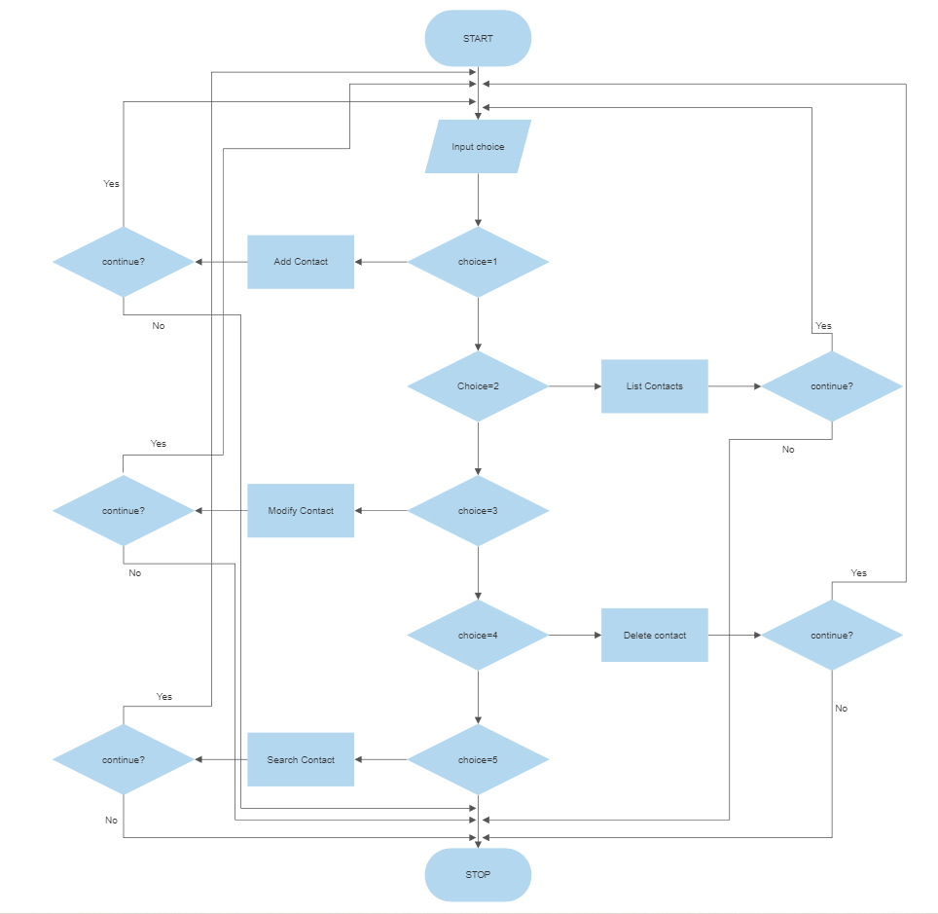

**Algorithm:-**

1. Input choice from the user.
2. if choice=1:

Add record to phonebook

Ask to continue

if user wants to continue:

Back to 1

else

End program

1. if choice=2:

list records of the phonebook

Ask to continue

if user wants to continue:

Back to 1

else

End program

1. if choice=3:

Modify a record of phonebook

Ask to continue

if user wants to continue:

Back to 1

else:

End program

1. if choice=4:

Delete record from phonebook

Ask to continue

if user wants to continue:

Back to 1

else

End program

1. if choice=5:

Search record in phonebook

Ask to continue

if user wants to continue:

Back to 1

else

End program

1. End Program.

**Code:**

#include<stdio.h>

#include<conio.h>

#include<string.h>

#include<stdlib.h>

#include<windows.h>

struct person

{

char name[35];

char address[50];

char father_name[35];

char mother_name[30];

long int mble_no;

char sex[8];

char mail[100];

char citision_no[20];

};

void menu();

void got();

void start();

void back();

void addrecord();

void listrecord();

void modifyrecord();

void deleterecord();

void searchrecord();

int main()

{

start();

return 0;

}

void back()

{

start();

}

void start()

{

menu();

}

void menu()

{

system("cls");

printf("\t\t**********WELCOME TO PHONEBOOK*************");

printf("\n\n\t\t\t MENU\t\t\n\n");

printf("\t1.Add New \t2.List \t3.Exit \n\t4.Modify \t5.Search\t6.Delete\n");

switch(getch())

{

case '1':

addrecord();

break;

case '2': listrecord();

break;

case '3': exit(0);

break;

case '4': modifyrecord();

break;

case '5': searchrecord();

break;

case '6': deleterecord();

break;

default:

system("cls");

printf("\nEnter 1 to 6 only");

printf("\nEnter any key to continue");

getch();

menu();

}

}

void addrecord()

{

system("cls");

FILE *f;

struct person p;

printf("\t*****Adding New Record to the Phonebook*****\n");

f=fopen("project","ab+");

printf("\n--------------------------------------");

printf("\nEnter name: ");

got(p.name);

printf("\nEnter the address: ");

got(p.address);

printf("\nEnter father's name: ");

got(p.father_name);

printf("\nEnter mother's name: ");

got(p.mother_name);

printf("\nEnter phone no.:");

scanf("%ld",&p.mble_no);

printf("Enter sex:");

got(p.sex);

printf("\nEnter e-mail:");

got(p.mail);

printf("\nEnter citizen no:");

got(p.citision_no);

fwrite(&p,sizeof(p),1,f);

printf("\n--------------------------------------");

fflush(stdin);

printf("\nRecord Saved Successfully!");

printf("\n--------------------------------------");

fclose(f);

printf("\nEnter any key to continue");

getch();

system("cls");

menu();

}

void listrecord()

{

system("cls");

printf("\t*****List of Records in the Phonebook*****\n");

printf("\n--------------------------------------");

struct person p;

FILE *f;

f=fopen("project","rb");

if(f==NULL)

{

printf("\nfile opening error in listing :");

exit(1);

}

while(fread(&p,sizeof(p),1,f)==1)

{

printf("\nYOUR RECORD IS");

printf("\nName=%s\nAdress=%s\nFather name=%s\nMother name=%s\nMobile no=%ld\nSex=%s\nE-mail=%s\nCitizen no=%s",p.name,p.address,p.father_name,p.mother_name,p.mble_no,p.sex,p.mail,p.citision_no);

getch();

//system("cls");

}

fclose(f);

printf("\n--------------------------------------");

printf("\nEnter any key to continue");

getch();

system("cls");

menu();

}

void searchrecord()

{

system("cls");

printf("\t*****Searching a Record in the Phonebook*****\n");

struct person p;

FILE *f;

char name[100];

f=fopen("project","rb");

if(f==NULL)

{

printf("\n error in opening\a\a\a\a");

exit(1);

}

printf("\nEnter name of person to search\n");

got(name);

printf("\n--------------------------------------\n");

while(fread(&p,sizeof(p),1,f)==1)

{

if(strcmp(p.name,name)==0)

{

printf("\n\tDetail Information About %s",name);

printf("\n\nName:%s\naddress:%s\nFather name:%s\nMother name:%s\nMobile no:%ld\nsex:%s\nE-mail:%s\nCitizen no:%s",p.name,p.address,p.father_name,p.mother_name,p.mble_no,p.sex,p.mail,p.citision_no);

printf("\n--------------------------------------");

}

else

{

printf("\nContact not found\n");

printf("\n--------------------------------------");

}

}

fclose(f);

printf("\nEnter any key to continue");

getch();

system("cls");

menu();

}

void deleterecord()

{

system("cls");

printf("\t*****Deleting a Record from the the Phonebook*****\n");

struct person p;

FILE *f,*ft;

int flag;

char name[100];

f=fopen("project","rb");

if(f==NULL)

{

printf("CONTACT'S DATA NOT ADDED YET.");

}

else

{

ft=fopen("temp","wb+");

if(ft==NULL)

printf("file opening error");

else

{

printf("\n--------------------------------------\n");

printf("ENTER CONTACT'S NAME:");

got(name);

fflush(stdin);

while(fread(&p,sizeof(p),1,f)==1)

{

if(strcmp(p.name,name)!=0)

fwrite(&p,sizeof(p),1,ft);

if(strcmp(p.name,name)==0)

flag=1;

}

fclose(f);

fclose(ft);

if(flag!=1)

{

printf("\nNO CONACT'S RECORD TO DELETE.");

remove("temp.txt");

}

else

{

remove("project");

rename("temp.txt","project");

printf("\nRECORD DELETED SUCCESSFULLY.");

printf("\n--------------------------------------");

}

}

}

printf("\nEnter any key to continue");

getch();

system("cls");

menu();

}

void modifyrecord()

{

system("cls");

printf("\t*****Modifying a Record in the Phonebook*****\n");

int c;

FILE *f;

int flag=0;

struct person p,s;

char name[50];

f=fopen("project","rb+");

if(f==NULL)

{

printf("CONTACT'S DATA NOT ADDED YET.");

exit(1);

}

else

{

system("cls");

printf("\nEnter CONTACT'S NAME TO MODIFY:\n");

got(name);

while(fread(&p,sizeof(p),1,f)==1)

{

if(strcmp(name,p.name)==0)

{

printf("\n Enter name:");

got(s.name);

printf("\nEnter the address:");

got(s.address);

printf("\nEnter father's name:");

got(s.father_name);

printf("\nEnter mother's name:");

got(s.mother_name);

printf("\nEnter phone no:");

scanf("%ld",&s.mble_no);

printf("\nEnter sex:");

got(s.sex);

printf("\nEnter e-mail:");

got(s.mail);

printf("\nEnter citizen no\n");

got(s.citision_no);

fseek(f,-sizeof(p),SEEK_CUR);

fwrite(&s,sizeof(p),1,f);

flag=1;

break;

}

fflush(stdin);

}

if(flag==1)

{

printf("\n your data id modified");

}

else

{

printf(" \n data is not found");

}

fclose(f);

}

printf("\n Enter any key to continue");

getch();

system("cls");

menu();

}

void got(char *name)

{

int i=0,j;

char c,ch;

do

{

c=getch();

if(c!=8&&c!=13)

{

*(name+i)=c;

putch(c);

i++;

}

if(c==8)

{

if(i>0)

{

i--;

}

system("cls");

for(j=0;j<i;j++)

{

ch=*(name+j);

putch(ch);

}

}

}while(c!=13);

*(name+i)='\0';

}

**Output Screen:**

First Screen -

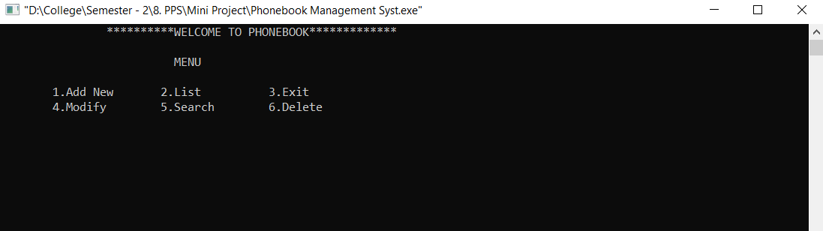

**-------------------------------------------------------------------------------------------**

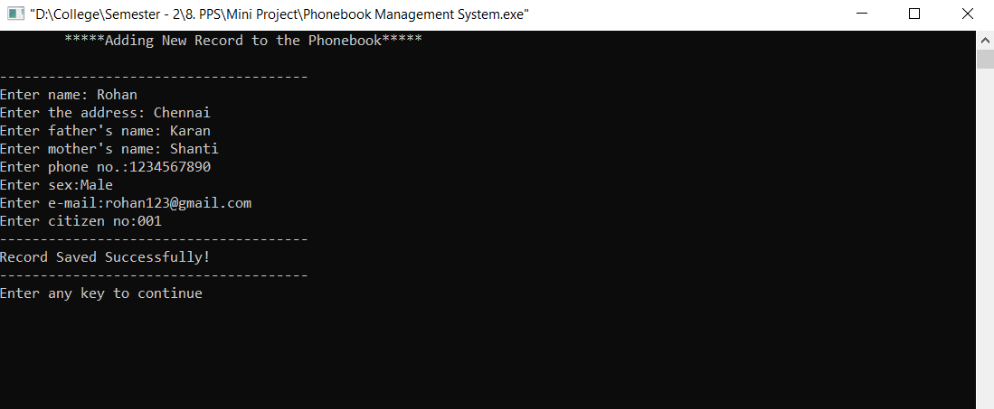Adding record to the phonebook -

**-------------------------------------------------------------------------------------------**

Displaying all the records in the phonebook -

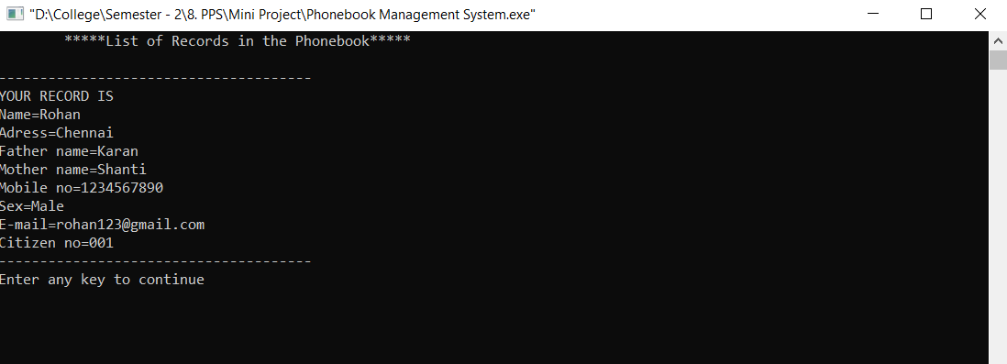

**-------------------------------------------------------------------------------------------**

Searching a Record in the phonebook –

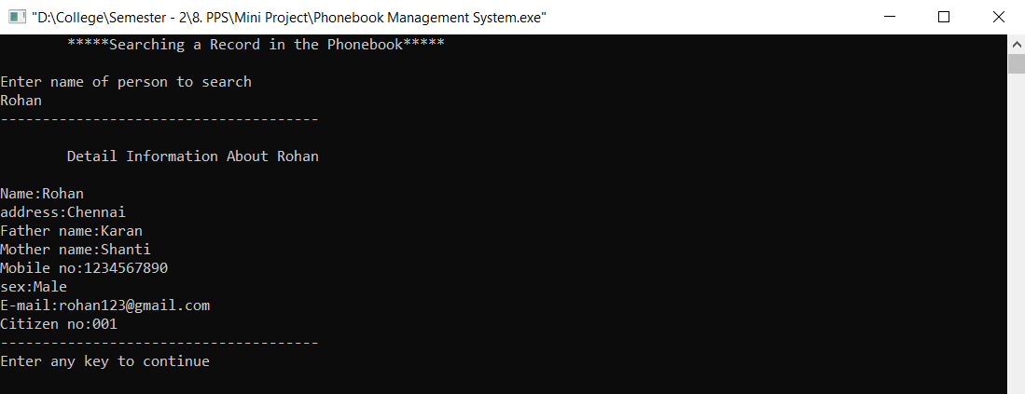

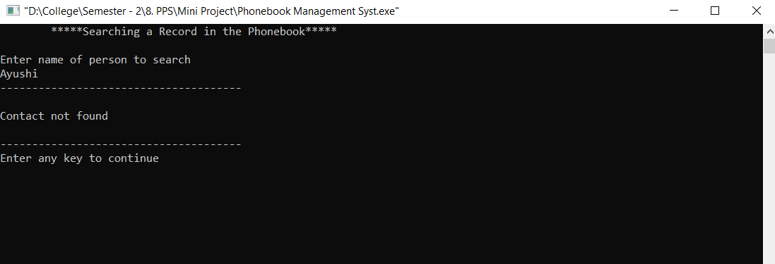

**---------------------------------------------------------------------------------------------------------**

Deleting a record from the phonebook –

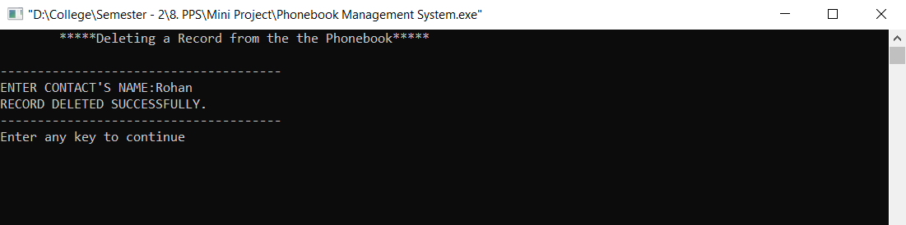

**-------------------------------------------------------------------------------------------**

**THANK YOU!**